CO–PO STUDENT ASSESSMENT REPORT | Student ID: 24-57223-2
INDIVIDUAL PROJECT ASSESSMENT | WEB TECHNOLOGIES
CO3 criteria, detailed components, and recorded student marks
Name | Fahim Shahariar | Student ID | 24-57223-2 | Group | 10 | Section | AA
Git Repo | https://github.com/utsho-9/CraveCart
CO3 ASSESSMENT
CO3: Develop multi-tier web application for targeted society
Feature Implementation (0-3) |  |  |  | Logical Analysis (0-3) |  |  | Completeness (0-3) |  | Total
Basic Web Security | UI (HTML/CSS) | Feature Completeness | Marks  (0-3) | DB | Auth (Session/cookie) | Marks  (0-3) | MVC | Marks  (0-3) | Total CO3 marks  (out of 9)
3.0 | 3.0 | 3.0 | 3.0 | 3.0 | 3.0 | 3.0 | 3.0 | 3.0 | 9.0
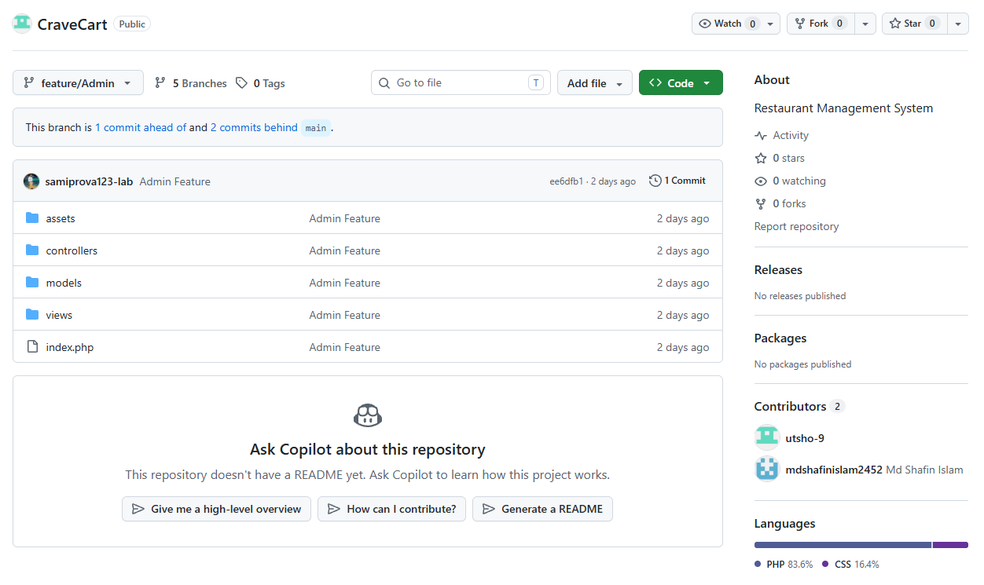
Repository Evidence
